[1]

**Name**: MWABILE ASSANI

**Roll number:** 09

**Registration number:** 12400162

**Section:** K24DJ

**Project Title:** BMI Calculator Website

**Course:** Internet Programming Laboratory CSE326

**Lovely Professional University, School of Computer Science and Engineering.**

**Table of contents**

**Introduction 3**

Purpose of the project 3

Technologies used 3

**Methodology 4**

1. Research and Planning 4

2. Development Process 5

3. Testing and Debugging 5

4. Tools and Resources Used 5

**Features 6**

Screenshots 7

**Testing 8**

1. Functional Testing 8

2. Input Validation Testing 8

3. Performance Testing 8

**Results 9**

1. Functionality 9

2. User Experience 9

4. Observations 9

**Conclusion 9**

**References 10**

**GitHub link for the project 10**

# Introduction

## Purpose of the project

The **Body Mass Index (BMI)** Calculator Website project aims to create a user-friendly and interactive tool that allows individuals to calculate their BMI based on height and weight. BMI is widely used to assess whether an individual is underweight, normal weight, overweight, or obese. By providing users with instant feedback on their BMI category, this website helps promote awareness of personal health and encourages users to make informed lifestyle decisions.

The project’s primary objective is to design and develop a functional website with an intuitive interface that performs BMI calculations efficiently. This involves ensuring that the tool is accessible to users of all technical backgrounds while maintaining accuracy in results.

## Technologies used

To achieve this, the following technologies were used:

* **HTML**: For structuring the website and creating the input fields, buttons, and result sections.
* **CSS**: To enhance the visual appeal and responsiveness of the website, ensuring it works seamlessly on various devices.
* **JavaScript**: For implementing the core logic of BMI calculation and dynamically displaying results based on user input.
* **Git and Github**: For version control and storing the project.

This project also demonstrates the importance of integrating basic programming concepts and web development skills to solve real-world problems and build practical solutions.

# Methodology

The development of the BMI Calculator Website followed a structured approach, ensuring a balance between functionality, user experience, and technical implementation. Below is a step-by-step outline of the methodology used to complete the project:

#### **1. Research and Planning**

* **Research**:
  + Studied the BMI formula and its categories (e.g. underweight, normal weight, overweight, obese).
  + Explored design inspirations for simple and accessible BMI calculators.
* **Planning**:
  + Defined the core features:
    - A slideshow to display some related pictures
    - Input fields for height and weight.
    - A button to calculate BMI.
    - Real-time display of BMI definition, formula, category, and some tips for maintaining a healthy BMI.

#### **2. Development Process**

1. **HTML (Structure)**:
   * Created a basic structure for the webpage using semantic HTML elements.
   * Added:
     + Slideshow
     + Input fields for height and weight.
     + A "Calculate BMI" button.
     + A section to display the results dynamically.
     + An accordion for definition, formula, categories, and tips.
2. **CSS (Styling)**:
   * Designed a clean, user-friendly interface:
     + Styled input fields, buttons, and the results section for better readability.
     + Improved the display of the accordion and the slideshow.
3. **JavaScript (Logic and Interaction)**:
   * Wrote the BMI calculation function:
     + Captured user inputs (height and weight).
     + Validated inputs to handle incorrect or missing values.
     + Calculated BMI using the formula and determined the corresponding category.
   * Added interactivity:
     + Linked the "Calculate BMI" button to trigger the calculation function.
     + Displayed results dynamically without reloading the page.

#### **3. Testing and Debugging**

* Conducted thorough testing:
  + **Functional Testing**: Checked whether BMI calculations were accurate for various inputs.
  + **Validation Testing**: Tested input restrictions (e.g. negative values, non-numeric inputs).
  + **Cross-Browser Testing**: Ensured compatibility across major web browsers like Chrome, Firefox, and Edge.
* Debugged issues with layout alignment and JavaScript functionality to ensure a smooth user experience.

#### **4. Tools and Resources Used**

* **Development Tools**:
  + VS Code: For writing and managing the project code.
  + Browser Developer Tools: For real-time testing and debugging.
* **Technologies**:
  + HTML, CSS, and JavaScript for building the website.
* **Version Control** (if applicable):
  + Git and GitHub were used to manage code versions and collaborate.

This methodology ensured the project met its goals efficiently while maintaining a focus on usability and technical accuracy.

# Features

* User-friendly input fields.
* Real-time BMI calculation and categorization (underweight, normal, overweight, obese).
* Responsive design.

## Screenshots

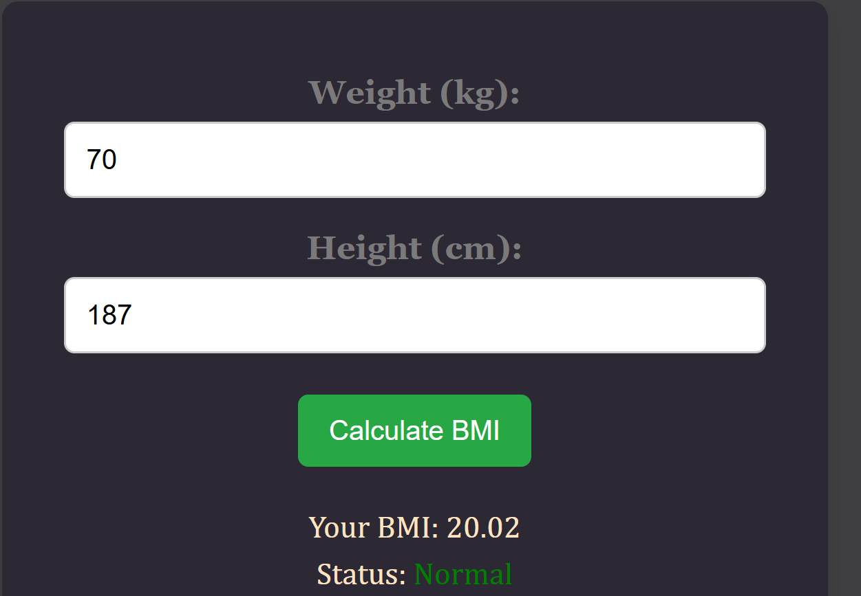

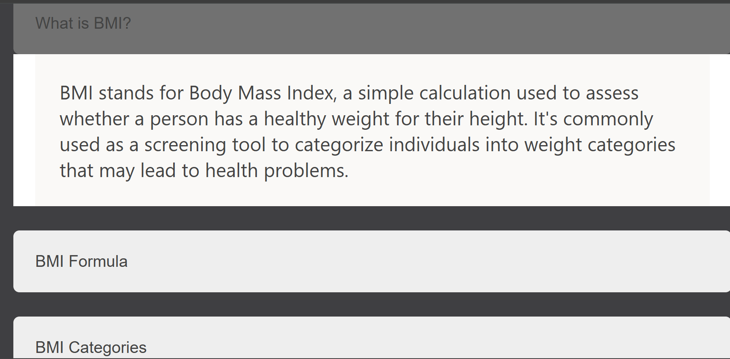



# Testing

Testing was a critical part of the project to ensure the functionality, accuracy, and usability of the BMI Calculator Website. The following types of tests were conducted:

#### **1. Functional Testing**

* Verified that the calculator accurately computes BMI using the formula
* Ensured the correct BMI category (underweight, normal weight, overweight, obese) was displayed for various inputs.

#### **2. Input Validation Testing**

* Tested how the website handled invalid inputs, such as:
  + Non-numeric values (e.g., letters or special characters).
  + Negative numbers or zero for height and weight.
  + Extremely large or small values.

#### **3. Performance Testing**

* Assessed the speed of BMI calculation and result display. The output was near-instantaneous, ensuring a smooth user experience.

# Results

The BMI Calculator Website was successfully developed and tested, achieving the following outcomes:

#### **1. Functionality**

* The website calculates BMI accurately for all valid inputs and dynamically displays the result along with the BMI category.
* Proper error messages are shown for invalid or missing inputs, enhancing usability.

#### **2. User Experience**

* The design is simple and intuitive, making it accessible to users of all technical backgrounds.
* Responsive design ensures a seamless experience on various devices and screen sizes.

#### **4. Observations**

* Strengths:
  + Accurate BMI calculations.
  + Real-time interactivity with JavaScript.
  + Clean and responsive design.
* Areas for Improvement:
  + Adding additional features like unit conversion (e.g., pounds to kilograms).
  + Implementing a feature to store or share results.

These results demonstrate the project's success in meeting its objectives while highlighting opportunities for future enhancements.

# Conclusion

From this project, I have learned :

* How to play with forms, images, and buttons, to build slideshows and accordions using HTML.
* How to build a friendly user interface, to decide where to place my HTML elements using CSS.
* How to implement the logic and to link it to my website using JavaScript.
* How to link my project to GitHub and control the changes using Git commands.
* How to manage my time and dedicate time to the project.

# References

<https://www.w3schools.com/> for learning slideshows and accordions.

<https://chatgpt.com/> for clearing some doubts and questions.

<https://www.youtube.com/> for tutorials

<https://code.visualstudio.com/> for writing the code

<https://github.com/> for hosting the project

<https://git-scm.com/> for version control

# GitHub link for the project

<https://github.com/Loic-Mwabile/BMI-calculator>

1.